UNITED STATES
SECURITIES AND EXCHANGE COMMISSION
Washington, D.C. 20549
SCHEDULE 14A
Proxy Statement Pursuant to Section 14(a) of the Securities
Exchange Act of 1934 (Amendment No. )
Filed by the Registrant ☒
Filed by a Party other than the Registrant ☐
Check the appropriate box:
☐ Preliminary Proxy Statement
☐ Confidential, for Use of the Commission Only (as permitted by Rule 14a-6(e)(2))
☐ Definitive Proxy Statement
☒ Definitive Additional Materials
☐ Soliciting Material under §240.14a-12
FTC Solar, Inc.
(Name of Registrant as Specified In Its Charter)

(Name of Person(s) Filing Proxy Statement, if other than the Registrant)
Payment of Filing Fee (Check all boxes that apply):
☒ No fee required.
☐ Fee paid previously with preliminary materials.
☐ Fee computed on table in exhibit required by Exchange Act Rules 14a-6(i)(1) and 0-11.

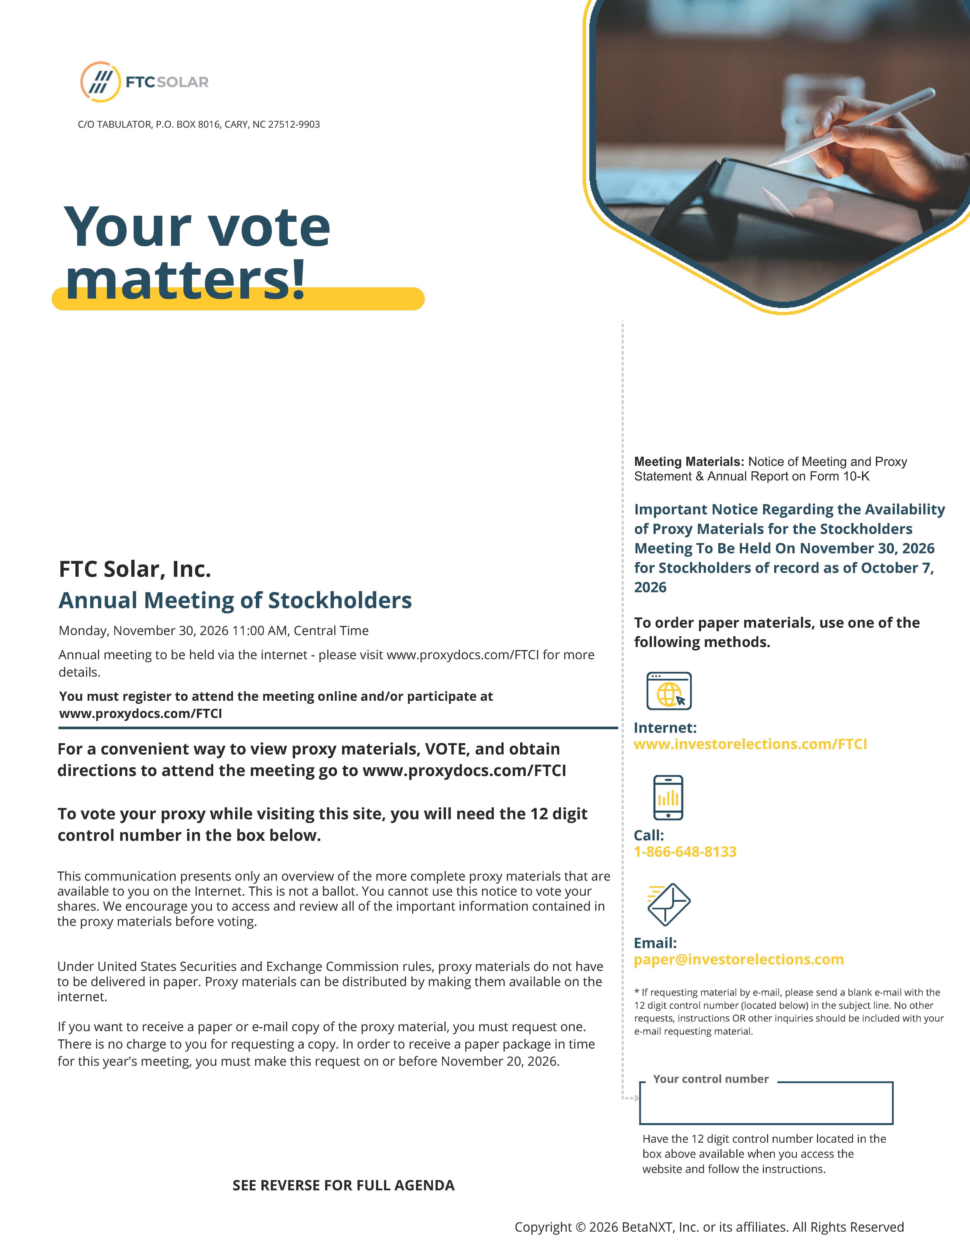

Your control number Your vote matters! Meeting Materials: Notice of Meeting and Proxy Statement & Annual Report on Form 10-K Important Notice Regarding the Availability of Proxy Materials for the Stockholders Meeting To Be Held On November 30, 2026 for Stockholders of record as of October 7, 2026 To order paper materials, use one of the following methods. Internet: www.investorelections.com/FTCI Call: 1-866-648-8133 Email: paper@investorelections.com * If requesting material by e-mail, please send a blank e-mail with the 12 digit control number (located below) in the subject line. No other requests, instructions OR other inquiries should be included with your e-mail requesting material. Have the 12 digit control number located in the box above available when you access the website and follow the instructions. Copyright © 2026 BetaNXT, Inc. or its affiliates. All Rights Reserved FTC Solar, Inc. Annual Meeting of Stockholders Monday, November 30, 2026 11:00 AM, Central Time Annual meeting to be held via the internet - please visit www.proxydocs.com/FTCI for more details. You must register to attend the meeting online and/or participate at www.proxydocs.com/FTCI For a convenient way to view proxy materials, VOTE, and obtain directions to attend the meeting go to www.proxydocs.com/FTCI To vote your proxy while visiting this site, you will need the 12 digit control number in the box below. This communication presents only an overview of the more complete proxy materials that are available to you on the Internet. This is not a ballot. You cannot use this notice to vote your shares. We encourage you to access and review all of the important information contained in the proxy materials before voting. Under United States Securities and Exchange Commission rules, proxy materials do not have to be delivered in paper. Proxy materials can be distributed by making them available on the internet. If you want to receive a paper or e-mail copy of the proxy material, you must request one. There is no charge to you for requesting a copy. In order to receive a paper package in time for this year's meeting, you must make this request on or before November 20, 2026. styleINA C/O TABULATOR, P.O. BOX 8016, CARY, NC 27512-9903 SEE REVERSE FOR FULL AGENDA

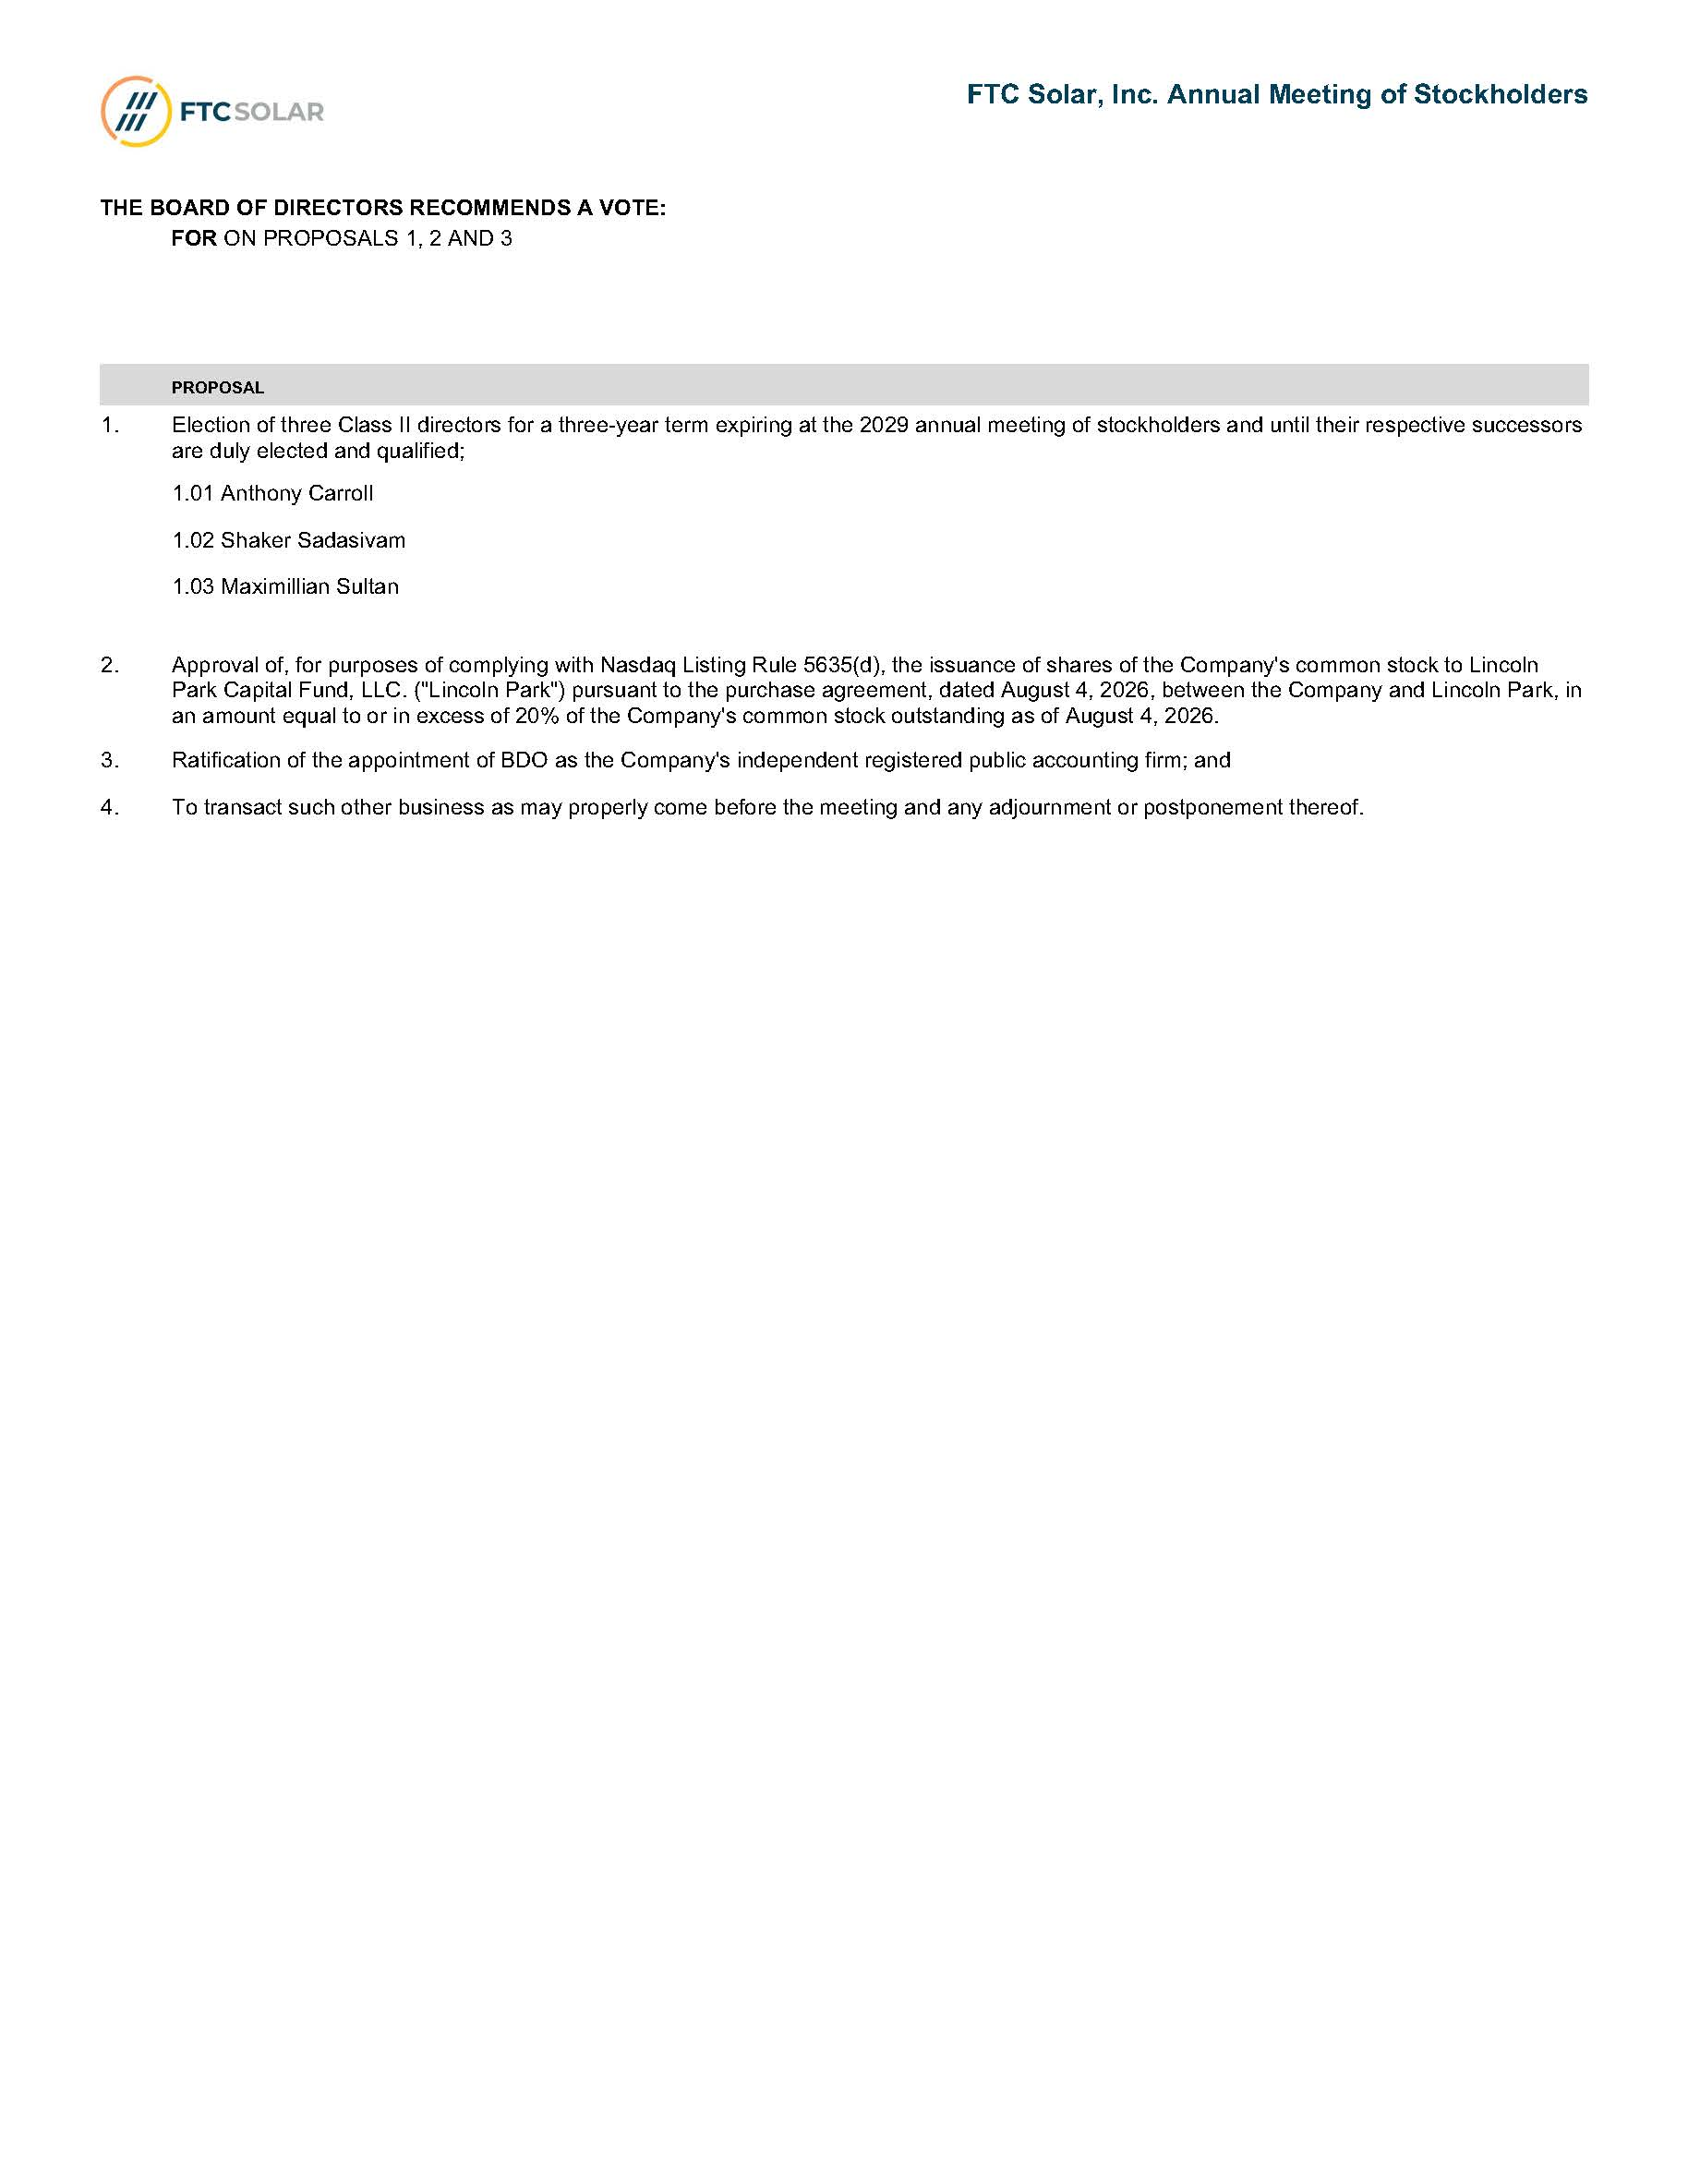
PROPOSAL 1. Election of three Class II directors for a three-year term expiring at the 2029 annual meeting of stockholders and until their respective successors are duly elected and qualified; 1.01 Anthony Carroll 1.02 Shaker Sadasivam 1.03 Maximillian Sultan 2. Approval of, for purposes of complying with Nasdaq Listing Rule 5635(d), the issuance of shares of the Company's common stock to Lincoln Park Capital Fund, LLC. ("Lincoln Park") pursuant to the purchase agreement, dated August 4, 2026, between the Company and Lincoln Park, in an amount equal to or in excess of 20% of the Company's common stock outstanding as of August 4, 2026. 3. Ratification of the appointment of BDO as the Company's independent registered public accounting firm; and 4. To transact such other business as may properly come before the meeting and any adjournment or postponement thereof. THE BOARD OF DIRECTORS RECOMMENDS A VOTE: FOR ON PROPOSALS 1, 2 AND 3 FTC Solar, Inc. Annual Meeting of Stockholders

